# 20210830
Эту задачу доделывал Черных Александр. Я ездил в СК по повесткам в это время.
Подробности здесь: https://tinkoff.slack.com/archives/C02CG5VPMLM

*. Задача SD "Примонтировать сетевые nfs-ресурсы с серверов drbd на серверы zeppelin" (https://forge.tcsbank.ru/case/5886812/info).
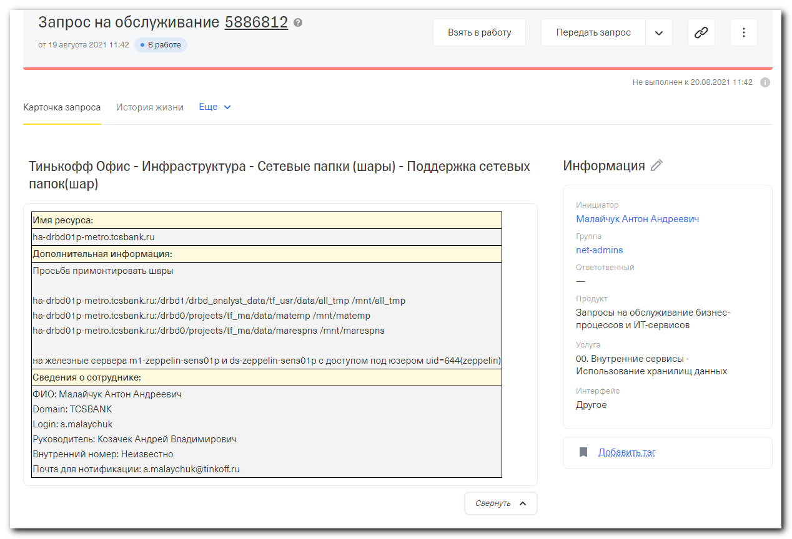

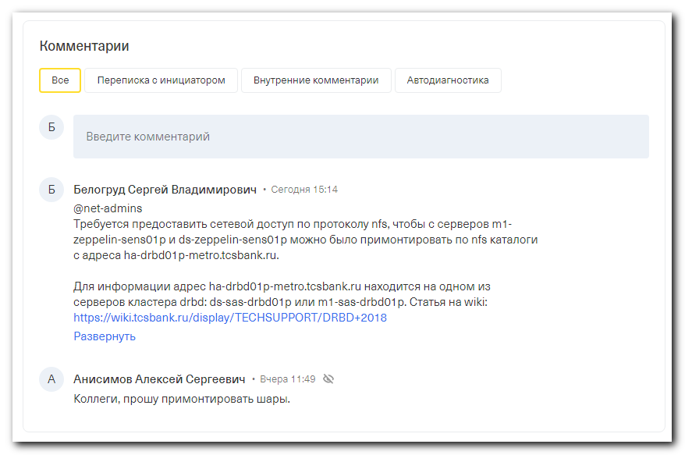
Белогруд Сергей Владимирович
• Сегодня 15:14
@net-admins
Требуется предоставить сетевой доступ по протоколу nfs, чтобы с серверов m1-zeppelin-sens01p и ds-zeppelin-sens01p можно было примонтировать по nfs каталоги с адреса ha-drbd01p-metro.tcsbank.ru.

Для информации адрес ha-drbd01p-metro.tcsbank.ru находится на одном из серверов кластера drbd: ds-sas-drbd01p или m1-sas-drbd01p. Статья на wiki: https://wiki.tcsbank.ru/display/TECHSUPPORT/DRBD+2018

Пояснения.
Я сделал настройки экспорта nfs-ресурсов на серверах ds-sas-drbd01p, m1-sas-drbd01p в файле /etc/exports.
Это настройки такого вида:
...
# SD https://forge.tcsbank.ru/case/5886812/info
# m1-zeppelin-sens01p.tcsbank.ru
/drbd1/drbd_analyst_data/tf_usr/data/all_tmp 10.212.41.17(rw,async,no_root_squash,no_subtree_check)
/drbd0/projects/tf_ma/data/matemp 10.212.41.17(rw,async,no_root_squash,no_subtree_check)
/drbd0/projects/tf_ma/data/marespns 10.212.41.17(rw,async,no_root_squash,no_subtree_check)
# ds-zeppelin-sens01p.tcsbank.ru
/drbd1/drbd_analyst_data/tf_usr/data/all_tmp 10.213.41.17(rw,async,no_root_squash,no_subtree_check)
/drbd0/projects/tf_ma/data/matemp 10.213.41.17(rw,async,no_root_squash,no_subtree_check)
/drbd0/projects/tf_ma/data/marespns 10.213.41.17(rw,async,no_root_squash,no_subtree_check)
...

В настоящий момент примонтировать nfs-ресурсы не получается. Диагностика показывает отсутствие разрешений сетевого доступа.
[root@m1-zeppelin-sens01p ~]# showmount -e ha-drbd01p-metro.tcsbank.ru
clnt_create: RPC: Port mapper failure - Timed out
[root@m1-zeppelin-sens01p ~]# rpcinfo -p ha-drbd01p-metro.tcsbank.ru
rpcinfo: can't contact portmapper: RPC: Remote system error - Connection timed out
[root@m1-zeppelin-sens01p ~]#

[root@ds-zeppelin-sens01p ~]# showmount -e ha-drbd01p-metro.tcsbank.ru
clnt_create: RPC: Port mapper failure - Timed out
[root@ds-zeppelin-sens01p ~]#
Свернуть

https://tinkoff.slack.com/archives/D612R3GA3/p1629459854000100
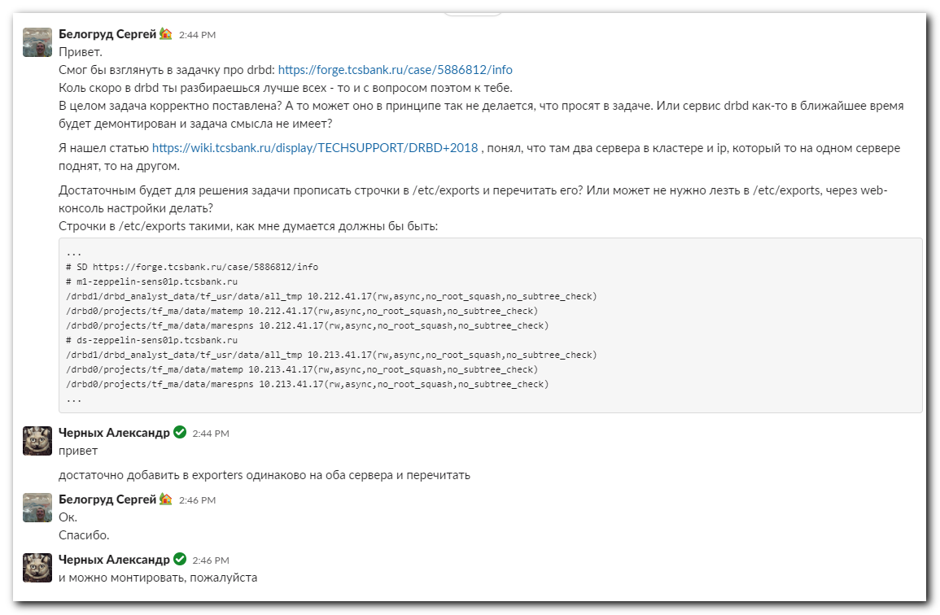

[root@m1-zeppelin-sens01p ~]# showmount -e ha-drbd01p-metro.tcsbank.ru
clnt_create: RPC: Port mapper failure - Timed out
[root@m1-zeppelin-sens01p ~]#

[s.belogrud@nb2339]# host ha-drbd01p-metro.tcsbank.ru
ha-drbd01p-metro.tcsbank.ru has address 10.217.65.157
[s.belogrud@nb2339]# host m1-zeppelin-sens01p
host: Host not found.
[s.belogrud@nb2339]# host m1-zeppelin-sens01p.tcsbank.ru
m1-zeppelin-sens01p.tcsbank.ru has address 10.212.41.17
[s.belogrud@nb2339]# host ds-zeppelin-sens01p.tcsbank.ru
ds-zeppelin-sens01p.tcsbank.ru has address 10.213.41.17
[s.belogrud@nb2339]#

[root@ds-sas-drbd01p ~]# ip a | grep -w inet
inet 127.0.0.1/8 scope host lo
inet 10.216.31.11/24 brd 10.216.31.255 scope global team0.1631
inet 10.216.31.13/24 brd 10.216.31.255 scope global secondary team0.1631
inet 10.217.49.6/24 brd 10.217.49.255 scope global team0.1749
inet 10.217.65.19/24 brd 10.217.65.255 scope global team0.1765
inet 10.217.65.157/24 brd 10.217.65.255 scope global secondary team0.1765
[root@ds-sas-drbd01p ~]#

[root@ds-sas-drbd01p ~]# ls -Alhd /drbd1/drbd_analyst_data/tf_usr/data/all_tmp /drbd0/projects/tf_ma/data/matemp /drbd0/projects/tf_ma/data/marespns
drwxrwxr-- 2 1996 1002 4.0K Jul 28 04:59 /drbd0/projects/tf_ma/data/marespns
drwxrwxr-- 3 1996 1002 1.7M Aug 20 14:05 /drbd0/projects/tf_ma/data/matemp
drwxrwxrwx 2 1063 1002 420K Aug 20 14:03 /drbd1/drbd_analyst_data/tf_usr/data/all_tmp
[root@ds-sas-drbd01p ~]#

[root@ds-sas-drbd01p ~]# vim -R /etc/exports
...
# SD https://forge.tcsbank.ru/case/5886812/info
# m1-zeppelin-sens01p.tcsbank.ru
/drbd1/drbd_analyst_data/tf_usr/data/all_tmp 10.212.41.17(rw,async,no_root_squash,no_subtree_check)
/drbd0/projects/tf_ma/data/matemp 10.212.41.17(rw,async,no_root_squash,no_subtree_check)
/drbd0/projects/tf_ma/data/marespns 10.212.41.17(rw,async,no_root_squash,no_subtree_check)
# ds-zeppelin-sens01p.tcsbank.ru
/drbd1/drbd_analyst_data/tf_usr/data/all_tmp 10.213.41.17(rw,async,no_root_squash,no_subtree_check)
/drbd0/projects/tf_ma/data/matemp 10.213.41.17(rw,async,no_root_squash,no_subtree_check)
/drbd0/projects/tf_ma/data/marespns 10.213.41.17(rw,async,no_root_squash,no_subtree_check)
...

[root@ds-sas-drbd01p ~]# exportfs -r
[root@ds-sas-drbd01p ~]#

[root@ds-sas-drbd01p ~]# exportfs | egrep -B 1 -ie "10.212.41.17|10.213.41.17"
/drbd1/drbd_analyst_data/tf_usr/data/all_tmp
10.212.41.17
/drbd1/drbd_analyst_data/tf_usr/data/all_tmp
10.213.41.17
/drbd0/projects/tf_ma/data/matemp
10.212.41.17
/drbd0/projects/tf_ma/data/matemp
10.213.41.17
/drbd0/projects/tf_ma/data/marespns
10.212.41.17
/drbd0/projects/tf_ma/data/marespns
10.213.41.17
[root@ds-sas-drbd01p ~]#

# Unusual note. On secondary server (where ip-address ha-drbd01p-metro.tcsbank.ru not rised) are not exist several directories.
#
[root@m1-sas-drbd01p ~]# vim /etc/exports
[root@m1-sas-drbd01p ~]# exportfs -r
exportfs: Failed to stat /drbd0/projects/tf_ma/data/marespns: No such file or directory
exportfs: Failed to stat /drbd0/projects/tf_ma/data/marespns: No such file or directory
exportfs: Failed to stat /drbd0/projects/tf_ma/data/matemp: No such file or directory
exportfs: Failed to stat /drbd0/projects/tf_ma/data/matemp: No such file or directory
[root@m1-sas-drbd01p ~]#

[root@m1-sas-drbd01p ~]# ip a | grep -w inet
inet 127.0.0.1/8 scope host lo
inet 10.216.31.10/24 brd 10.216.31.255 scope global team0.1631
inet 10.217.49.7/24 brd 10.217.49.255 scope global team0.1749
inet 10.217.65.20/24 brd 10.217.65.255 scope global team0.1765
[root@m1-sas-drbd01p ~]#

[root@m1-sas-drbd01p ~]# ls -Alhd /drbd1/drbd_analyst_data/tf_usr/data/all_tmp /drbd0/projects/tf_ma/data/matemp /drbd0/projects/tf_ma/data/marespns
ls: cannot access /drbd0/projects/tf_ma/data/matemp: No such file or directory
ls: cannot access /drbd0/projects/tf_ma/data/marespns: No such file or directory
drwxr-xr-x 2 root root 6 Jun 6 2018 /drbd1/drbd_analyst_data/tf_usr/data/all_tmp
[root@m1-sas-drbd01p ~]#

[root@m1-sas-drbd01p ~]# exportfs | egrep -B 1 -ie "10.212.41.17|10.213.41.17"
/drbd1/drbd_analyst_data/tf_usr/data/all_tmp
10.212.41.17
/drbd1/drbd_analyst_data/tf_usr/data/all_tmp
10.213.41.17
/drbd0/projects/tf_ma/data/matemp
10.212.41.17
/drbd0/projects/tf_ma/data/matemp
10.213.41.17
/drbd0/projects/tf_ma/data/marespns
10.212.41.17
/drbd0/projects/tf_ma/data/marespns
10.213.41.17
[root@m1-sas-drbd01p ~]#

[root@m1-zeppelin-sens01p ~]# showmount -e ha-drbd01p-metro.tcsbank.ru
clnt_create: RPC: Port mapper failure - Timed out
[root@m1-zeppelin-sens01p ~]# rpcinfo -p ha-drbd01p-metro.tcsbank.ru
rpcinfo: can't contact portmapper: RPC: Remote system error - Connection timed out
[root@m1-zeppelin-sens01p ~]#

# For example, how it have to be.
#
[root@m1-zeppelin-sens01p ~]# mount -t nfs
FS-SENSDATA:/zeppelin_pd on /mnt/zeppelin-exchange type nfs (rw,relatime,vers=3,rsize=32768,wsize=32768,namlen=255,hard,proto=tcp,timeo=600,retrans=2,sec=sys,mountaddr=10.217.180.35,mountvers=3,mountport=635,mountproto=tcp,local_lock=none,addr=10.217.180.35)
[root@m1-zeppelin-sens01p ~]#

[root@m1-zeppelin-sens01p ~]# rpcinfo -p FS-SENSDATA
program vers proto port service
100000 2 udp 111 portmapper
100000 2 tcp 111 portmapper
100000 3 udp 111 portmapper
100000 3 tcp 111 portmapper
100000 4 udp 111 portmapper
100000 4 tcp 111 portmapper
100003 3 udp 2049 nfs
100003 3 tcp 2049 nfs
100005 1 udp 635 mountd
100005 2 udp 635 mountd
100005 3 udp 635 mountd
100005 1 tcp 635 mountd
100005 2 tcp 635 mountd
100005 3 tcp 635 mountd
100021 4 udp 4045 nlockmgr
100021 4 tcp 4045 nlockmgr
100024 1 udp 4046 status
100024 1 tcp 4046 status
[root@m1-zeppelin-sens01p ~]#

# The second server has same troubles to access via nfs.
#
[root@ds-zeppelin-sens01p ~]# showmount -e ha-drbd01p-metro.tcsbank.ru
clnt_create: RPC: Port mapper failure - Timed out
[root@ds-zeppelin-sens01p ~]#

https://wiki.tcsbank.ru/display/TECHSUPPORT/DRBD+2018
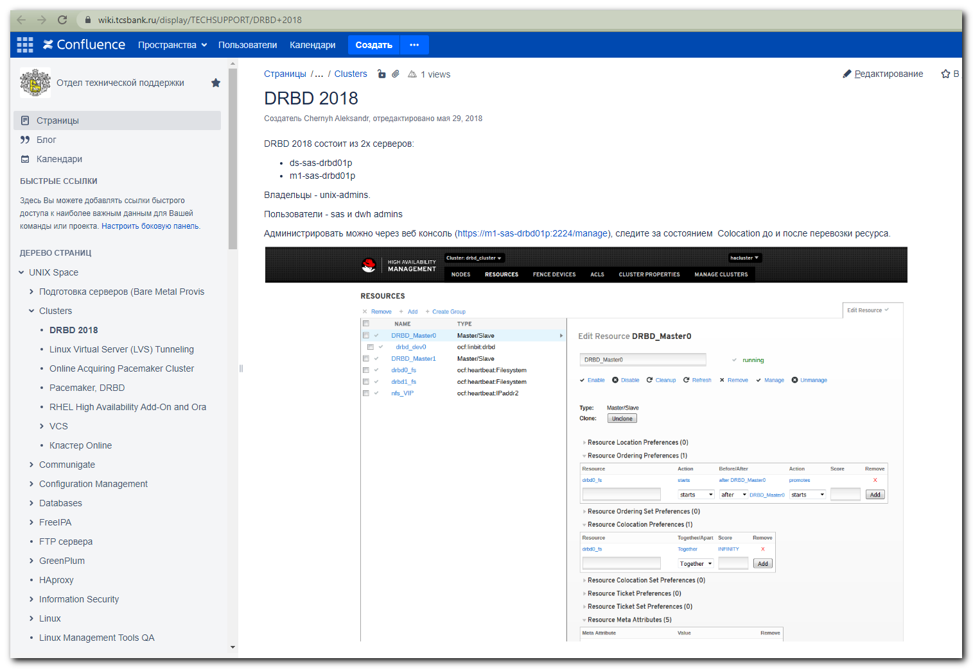

https://wiki.tcsbank.ru/pages/viewpage.action?pageId=921737281
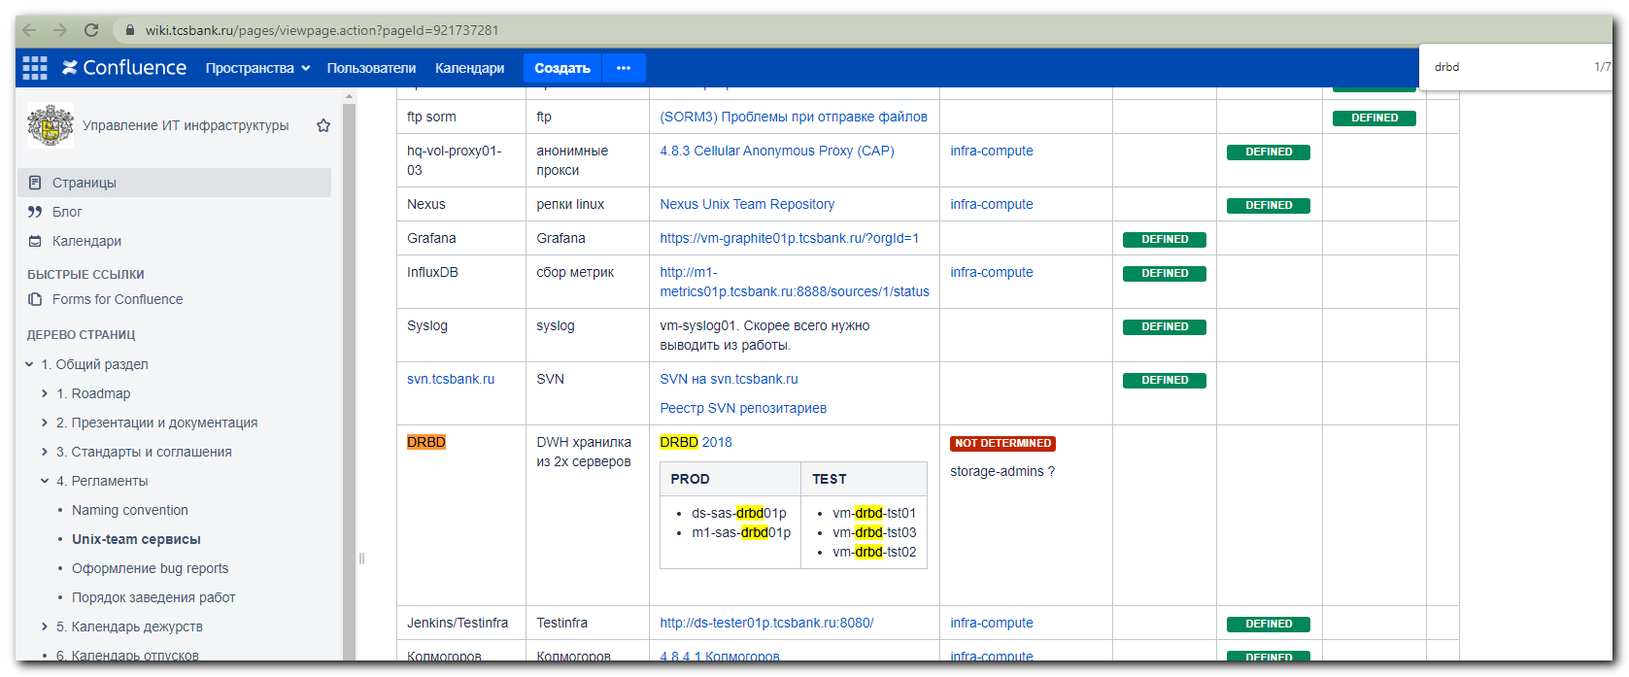

#
# 20210824
#
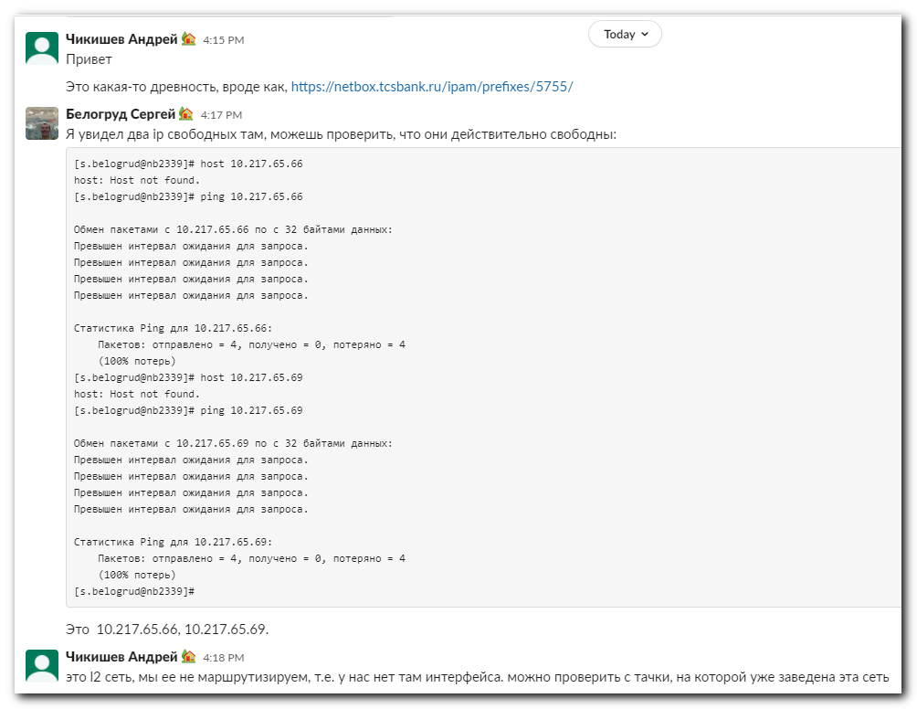
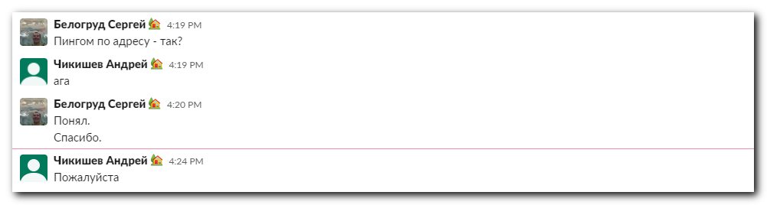

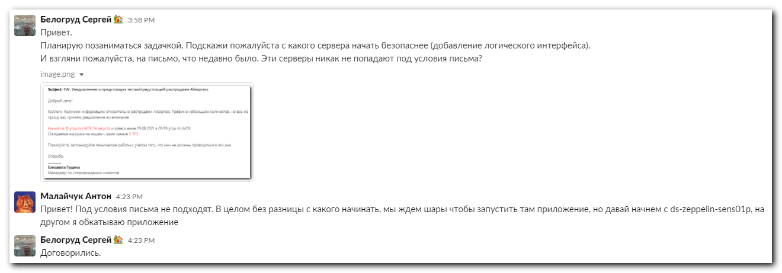

# 20210824
#
[root@ds-sas-drbd01p ~]# ping -c 3 -I 10.217.65.19 10.217.65.69
PING 10.217.65.69 (10.217.65.69) from 10.217.65.19 : 56(84) bytes of data.
From 10.217.65.19 icmp_seq=1 Destination Host Unreachable
From 10.217.65.19 icmp_seq=2 Destination Host Unreachable
From 10.217.65.19 icmp_seq=3 Destination Host Unreachable

--- 10.217.65.69 ping statistics ---
3 packets transmitted, 0 received, +3 errors, 100% packet loss, time 1999ms
pipe 3
[root@ds-sas-drbd01p ~]#

[root@ds-sas-drbd01p ~]# ping -c 3 -I 10.217.65.19 10.217.65.86
PING 10.217.65.86 (10.217.65.86) from 10.217.65.19 : 56(84) bytes of data.
From 10.217.65.19 icmp_seq=1 Destination Host Unreachable
From 10.217.65.19 icmp_seq=2 Destination Host Unreachable
From 10.217.65.19 icmp_seq=3 Destination Host Unreachable

--- 10.217.65.86 ping statistics ---
3 packets transmitted, 0 received, +3 errors, 100% packet loss, time 2000ms
pipe 3
[root@ds-sas-drbd01p ~]#

[s.belogrud@nb2339]# host 10.217.65.86
host: Host not found.
[s.belogrud@nb2339]#

# These ip addresses are free. I use it.
10.217.65.69
10.217.65.86

[root@ds-sas-drbd01p ~]# cat /etc/redhat-release
Red Hat Enterprise Linux Server release 7.5 (Maipo)
[root@ds-sas-drbd01p ~]#

[root@ds-zeppelin-sens01p ~]# ip a | grep -w inet
inet 127.0.0.1/8 scope host lo
inet 10.213.41.17/24 brd 10.213.41.255 scope global bond0.1341
[root@ds-zeppelin-sens01p ~]# cat /etc/redhat-release
CentOS Linux release 7.6.1810 (Core)
[root@ds-zeppelin-sens01p ~]#

[root@ds-zeppelin-sens01p ~]# ls -1 /etc/sysconfig/network-scripts/ifcfg-*
/etc/sysconfig/network-scripts/ifcfg-bond0
/etc/sysconfig/network-scripts/ifcfg-bond0.1341
/etc/sysconfig/network-scripts/ifcfg-eno5
/etc/sysconfig/network-scripts/ifcfg-eno6
/etc/sysconfig/network-scripts/ifcfg-lo
[root@ds-zeppelin-sens01p ~]# mkdir -p ~/work/20210824-1634/backup
[root@ds-zeppelin-sens01p ~]# cp /etc/sysconfig/network-scripts/ifcfg-* ~/work/20210824-1634/backup/
[root@ds-zeppelin-sens01p ~]# vim -o /etc/sysconfig/network-scripts/ifcfg-bond0.1341 /etc/sysconfig/network-scripts/ifcfg-bond0.1765
2 files to edit
[root@ds-zeppelin-sens01p ~]# if up bond0.1765
>
[root@ds-zeppelin-sens01p ~]# ifup bond0.1765
[root@ds-zeppelin-sens01p ~]# ip a | grep -w inet
inet 127.0.0.1/8 scope host lo
inet 10.213.41.17/24 brd 10.213.41.255 scope global bond0.1341
inet 10.217.65.69/24 brd 10.217.65.255 scope global bond0.1765
[root@ds-zeppelin-sens01p ~]#

[root@ds-zeppelin-sens01p ~]# cat /etc/sysconfig/network-scripts/ifcfg-bond0.1765
DEVICE=bond0.1765
BOOTPROTO=none
ONBOOT=yes
USERCTL=no
NM_CONTROLLED=no
VLAN=yes
IPV6INIT=no
IPADDR=10.217.65.69
NETMASK=255.255.255.0
MTU=9000
[root@ds-zeppelin-sens01p ~]#

# Test availability this subnet. I know, that address 10.217.65.66 available for ping.
# But here it is not.
[root@ds-zeppelin-sens01p ~]# ping -c 3 -I 10.217.65.69 10.217.65.66
PING 10.217.65.66 (10.217.65.66) from 10.217.65.69 : 56(84) bytes of data.
From 10.217.65.69 icmp_seq=1 Destination Host Unreachable
From 10.217.65.69 icmp_seq=2 Destination Host Unreachable
From 10.217.65.69 icmp_seq=3 Destination Host Unreachable

--- 10.217.65.66 ping statistics ---
3 packets transmitted, 0 received, +3 errors, 100% packet loss, time 1999ms
pipe 3
[root@ds-zeppelin-sens01p ~]#

[s.belogrud@nb2339]# ssh bsv@m1-zeppelin-sens01p
Last login: Fri Aug 20 14:54:05 2021 from 172.30.154.212
[bsv@m1-zeppelin-sens01p ~]$ sudo -i
[root@m1-zeppelin-sens01p ~]# ip a | grep -w inet
inet 127.0.0.1/8 scope host lo
inet 10.212.41.17/24 brd 10.212.41.255 scope global bond0.1241
[root@m1-zeppelin-sens01p ~]# ls -1 /etc/sysconfig/network-scripts/ifcfg-*
/etc/sysconfig/network-scripts/ifcfg-bond0
/etc/sysconfig/network-scripts/ifcfg-bond0.1241
/etc/sysconfig/network-scripts/ifcfg-eno5
/etc/sysconfig/network-scripts/ifcfg-eno6
/etc/sysconfig/network-scripts/ifcfg-lo
[root@m1-zeppelin-sens01p ~]# cat /etc/redhat-release
CentOS Linux release 7.6.1810 (Core)
[root@m1-zeppelin-sens01p ~]# mkdir -p ~/work/20210824-1644/backup
[root@m1-zeppelin-sens01p ~]# cp /etc/sysconfig/network-scripts/ifcfg-* ~/work/20210824-1644/backup/
[root@m1-zeppelin-sens01p ~]# vim -o /etc/sysconfig/network-scripts/ifcfg-bond0.1241 /etc/sysconfig/network-scripts/ifcfg-bond0.1765
2 files to edit
[root@m1-zeppelin-sens01p ~]# ifup bond0.1765
[root@m1-zeppelin-sens01p ~]# ip a | grep -w inet
inet 127.0.0.1/8 scope host lo
inet 10.212.41.17/24 brd 10.212.41.255 scope global bond0.1241
inet 10.217.65.86/24 brd 10.217.65.255 scope global bond0.1765
[root@m1-zeppelin-sens01p ~]#

